**10. Real Time Sign Language Recognition Using PCA**

Gesture Recognition System Can Be Classified Into Two Types, The First Is The Use Of Electromechanical Devices And The Other Is Not Using Any Devices Which Might Affect The Signer's Natural Signing Ability. Various Works Have Been Carried Out Previously On Various Sign Language Recognition Techniques, Including A Novel Method For SLR Based On EMG Sensors With A Data Glove. Preprocessing Consist Image Acquisition, Segmentation And Morphological Filtering Methods. Otsu Algorithm Is Used For Segmentation Purpose. Feature Extraction Is Vital To Gesture Recognition.

In The Training Phase, Each Gesture Is Represented As A Column Vector. These Gesture Vectors Are Then Normalized With Respect To Average Gesture. Next, The Algorithm Finds The Eigenvectors Of The Covariance Matrix Of Normalized Gestures. This Eigenvector Is Then Multiplied By Each Of The Gesture Vectors To Obtain The Corresponding Gesture Space Projections. The Proposed Procedure Was Implemented And Tested With A Preprocessed Gesture Taken As Input For Feature Extraction.

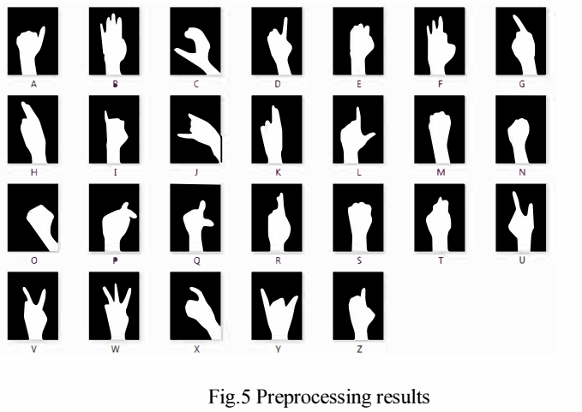

The Preprocessing Results Of The Same Are Shows In Fig.5. A Set Of 26 Images Of Single Person Is Used For Training Database Which Are Captured By Web Cam In White Background. Finally, Recognized Sign Is Converted Into Text And Voice Alphabet.